Mulla Mulla
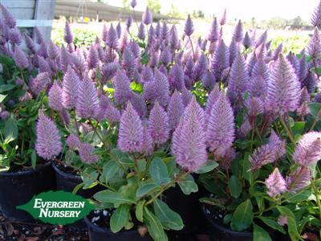
4 flower heads would be great please, with some leaves

